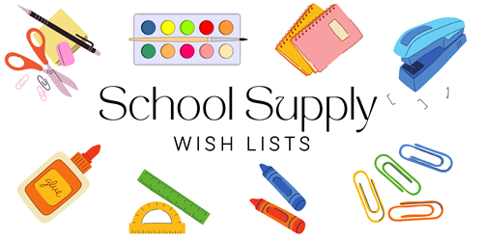

**3rd GRADE – DUAL LANGUAGE ONLY**

**24/25**

24 #2 TIONDEROGA PENCILS (SHARPENED)

5 COMPOSITION NOTEBOOKS – ANY COLOR

1 PACK OF BLACK EXPO MARKERS

1 PAIR OF FISKAR SCISSORS

8 ELMER GLUE STICKS

2 REAMS OF COPY PAPER

1 PAIR OF HEADPHONES OR EARBUDS

3 PLASTIC FOLDERS WITH PRONGS (1 RED, 1 YELLOW & 1 GREEN)

1 PACK OF 3 x 5 INDEX CARDS

1 SPIRAL NOTEBOOK FOR SPECIALS – ANY COLOR

2 LANYARDS WITH ID HOLDER

1 MUSICAL RECORDS FOR MUSIC CLASS

1 PACK OF CRAYOLA CRAYONS (24ct)

1 PACK OF LARGE ERASERS

**GIRLS ONLY:**

1 PACK OF CRAYOLA COLORED PENCILS (24ct)

1 CONTAINER OF CLOROX WIPES

4 MAGIC ERASERS

1 BOX OF QUART SIZE ZIPLOC BAGS

**BOYS ONLY:**

4 PACKS OF HIGHLIGHTERS

1 BOX OF TISSUES

1 PACKAGE OF POST IT NOTES – 3 x 3

1 BOX OF GALLON SIZE ZIPLOC BAGS

**\*\*Teachers may have additional items they will request at the Meet and Greet or Open House\*\***